1. Main repository: <https://github.com/nithinsreeraj/bookmyshow>
2. Have one folder as your local repository and have use another location as the eclipse workspace.

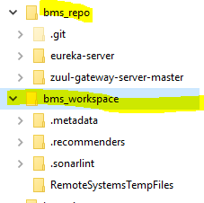

1. Git bash inside the repo folder(bms_repo) and execute the following:
   1. git init
   2. git remote add main <https://github.com/nithinsreeraj/bookmyshow>
   3. git pull main master
   4. git config --global core.autocrlf true
2. Launch the eclipse workspace and import each of the pulled project as “existing maven project”.
3. Verify whether the java code formatter is set to “Eclipse built in” for all our projects.
   1. windows -> preferences
   2. ->java -> code style -> formatter
   3. ->configure project specific settings
   4. -> (select the microservice project) ->OK
   5. -> check "enable project specific settings"
   6. ->choose "eclipse built in" as the active profile ->apply
4. Increase the remote connection timeout (IF you are using Eclipse to push/pull etc.)
   1. Windows -> Preferences
   2. Team -> Git

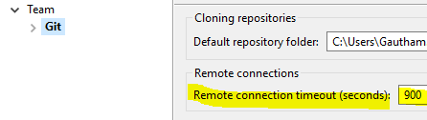

WHEN CREATING A NEW PROJECT

1. Make sure to use the spring snapshot "2.1.2(snapshot)" when creating the project from start.spring.io
2. Extract the zip to repo(bms_repo)
3. To push your changes
   1. Git bash @ bms_repo
   2. git add <folder-name>/*
   3. git commit –m “<commit-message>”
   4. git push main master
4. Pull all the changes from the main before performing a push.

If there are any errors after importing a maven project, then try the following method:

* 1. right click on project
  2. -> maven
  3. ->update project
  4. ->check "force update of snapshots/releases" -> OK

